**Data Base Systems I**

**CSC322**

**Initial Project Report**

**Title: Payroll Management System using MySQL Database**



|  |  |
| --- | --- |
| **Name:** | *Manahil Fayyaz, Tayyaba* |
| **Registration Number:** | *FA21-BCE-039, FA21-BCE-093* |
| **Class:** | *BCE-5A* |
| **Instructor’s Name:** | *Asad Ali Malik* |

**Payroll Management System**

In this lab, we executed the methods of data insertion, alteration and apply different types of constraints outlined for our project.

**Updating tables:**

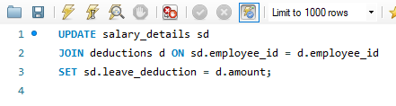

**Alteration in Tables:**

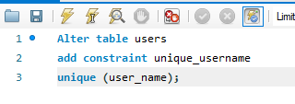

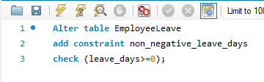



**Insertion of data in tables:**

1. **Employee:**

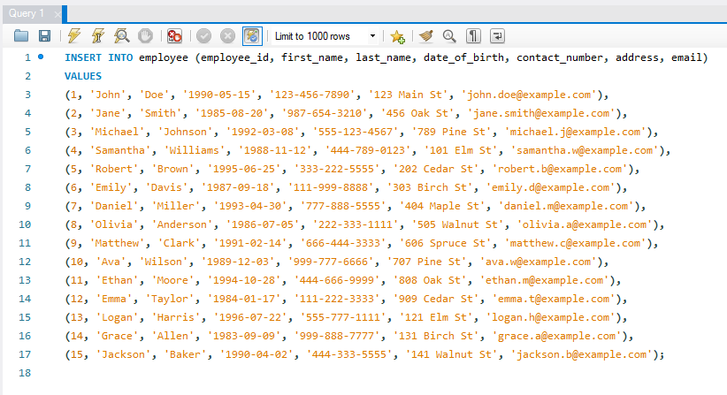

1. **Salary_details:**

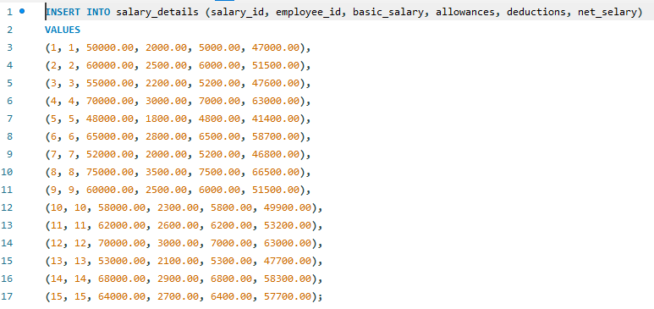

1. **deductions:**

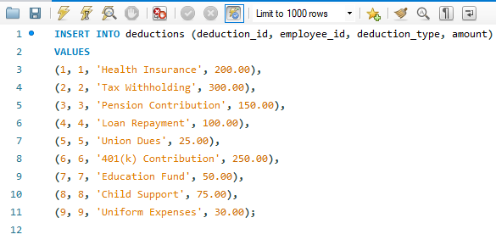

1. **Attendence:**

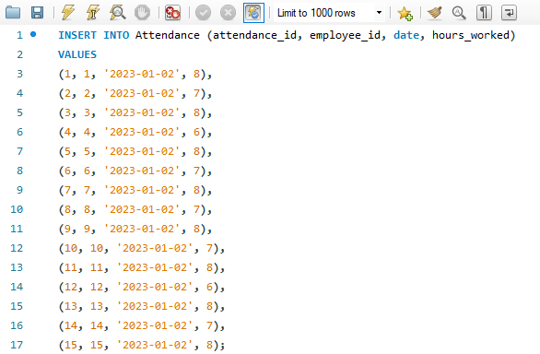

1. **payroll_log:**

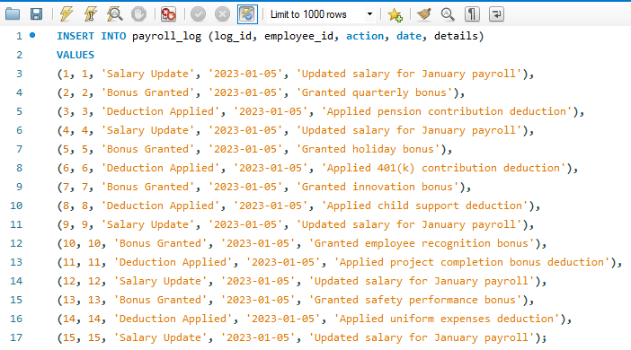

1. **tax_details:**

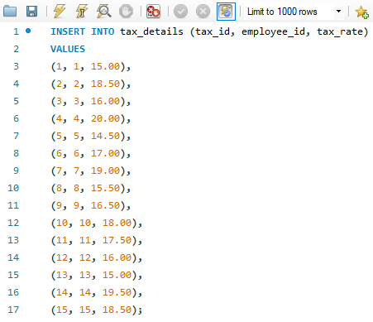

1. **departments:**

